**KWAME NKRUMAH UNIVERSITY OF SCIENCE AND TECHNOLOGY**

**COLLEGE OF SCIENCE**

**DEPARTMENT OF COMPUTER SCIENCE**

****

**MINI - PROJECT DOCUMENTATION**

**PROJECT TOPIC**

**FACE DETECTION ATTENDANCE SYSTEM**

**PRESENTED BY:**

**NAME CONTACT INDEX NUMBER**

**SAMUEL WILLIAMS QUAYNOR 0504638295/0557007356 4620518**

Table of Contents

Table of Contents

[Abstract 4](#_Toc81671339)

[1.1. Introduction 6](#_Toc81671340)

[1.2. Background 6](#_Toc81671341)

[1.3. Problem Statement 8](#_Toc81671342)

[1.4. Aims and Objectives 9](#_Toc81671343)

[1.5. Flow Chart 10](#_Toc81671344)

[1.6. Scope of the project 11](#_Toc81671345)

[2.1. Student Attendance System 13](#_Toc81671346)

[2.2. Digital Image Processing 13](#_Toc81671347)

[2.3. Image Representation in a Digital Computer 14](#_Toc81671348)

[2.4. Steps in Digital Image Processing 14](#_Toc81671349)

[2.5. Definition of Terms and History 15](#_Toc81671350)

[3.1. Introduction 24](#_Toc81671351)

[3.2. Tools and Technologies 25](#_Toc81671352)

[3.3. Python 25](#_Toc81671354)

[3.4. Django 25](#_Toc81671355)

[3.5. OpenCv 26](#_Toc81671356)

[3.6. Model Implementation 26](#_Toc81671357)

[3.7. System Design 26](#_Toc81671358)

### Abstract

Uniqueness or individuality of an individual face is the representation of one’s identity. In this project face of an individual is used for the purpose of attendance making automatically. Attendance of the student is very important for every college, universities and school. Conventional methodology for taking attendance is by calling the name or roll number of the student and the attendance is recorded. Time consumption for this purpose is an important point of concern. Assume that the duration for one subject is around 60 minutes or 1 hour & to record attendance takes 5 to 10 minutes. For every tutor this is consumption of time. To stay away from these losses, an automatic process is used in this project which is based on image processing. In this project face detection and face recognition is used. Face detection is used to locate the position of face region and face recognition is used for marking the understudy’s attendance. The database of all the students in the class is stored and when the face of the individual student matches with one of the faces stored in the database then the attendance is recorded.

Chapter 1

Introduction

## Introduction

Attendance is prime important for both the teacher and student of an educational organization. So it is very important to keep record of the attendance. The problem arises when we think about the traditional process of taking attendance in class room.

Calling name or roll number of the student for attendance is not only a problem of time consumption but also it needs energy. So an automatic attendance system can solve all above problems.

There are some automatic attendances making system which are currently used by much institution. One of such system is biometric technique and RFID system. Although it is automatic and a step ahead of traditional method it fails to meet the time constraint. The student has to wait in queue for giving attendance, which is time taking.

This project introduces an involuntary attendance marking system, devoid of any kind of interference with the normal teaching procedure. The system can be also implemented during exam sessions or in other teaching activities where attendance is highly essential. This system eliminates classical student identification such as calling name of the student, or checking respective identification cards of the student, which can not only interfere with the ongoing teaching process, but also can be stressful for students during examination sessions. In addition, the students have to register in the database to be recognized. The enrolment can be done on the spot through the user-friendly interface.

## Background

Face recognition is crucial in daily life in order to identify family, friends or someone we are familiar with. We might not perceive that several steps have actually taken in order to identify human faces. Human intelligence allows us to receive information and interpret the information in the recognition process. We receive information through the image projected into our eyes, by specifically retina in the form of light. Light is a form of electromagnetic waves which are radiated from a source onto an object and projected to human vision. Robinson-Riegler,

G., & Robinson-Riegler, B. (2008) mentioned that after visual processing done by the human visual system, we actually classify shape, size, contour and the texture of the object in order to analyze the information. The analyzed information will be compared to other representations of objects or face that exist in our memory to recognize. In fact, it is a hard challenge to build an automated system to have the same capability as a human to recognize faces. However, we need large memory to recognize different faces, for example, in the Universities, there are a lot of students with different race and gender, it is impossible to remember every face of the individual without making mistakes. In order to overcome human limitations, computers with almost limitless memory, high processing speed and power are used in face recognition systems.

The human face is a unique representation of individual identity. Thus, face recognition is defined as a biometric method in which identification of an individual is performed by comparing real-time capture image with stored images in the database of that person (Margaret Rouse, 2012).

Nowadays, face recognition system is prevalent due to its simplicity and awesome performance. For instance, airport protection systems and FBI use face recognition for criminal investigations by tracking suspects, missing children and drug activities (Robert Silk, 2017). Apart from that, Facebook which is a popular social networking website implement face recognition to allow the users to tag their friends in the photo for entertainment purposes (Sidney Fussell, 2018). Furthermore, Intel Company allows the users to use face recognition to get access to their online account (Reichert, C., 2017). Apple allows the users to unlock their mobile phone, iPhone X by using face recognition (deAgonia, M., 2017).

The work on face recognition began in 1960. Woody Bledsoe, Helen Chan Wolf and Charles Bisson had introduced a system which required the administrator to locate eyes, ears, nose and mouth from images. The distance and ratios between the located features and the common reference points are then calculated and compared. The studies are further enhanced by Goldstein, Harmon, and Lesk in 1970 by using other features such as hair colour and lip thickness to automate the recognition. In 1988, Kirby and Sirovich first suggested principle component analysis (PCA) to solve face recognition problem. Many studies on face recognition

were then conducted continuously until today (Ashley DuVal, 2012).

## Problem Statement

Traditional student attendance marking technique is often facing a lot of trouble. The face recognition student attendance system emphasizes its simplicity by eliminating classical student attendance marking technique such as calling student names or checking respective identification cards. There are not only disturbing the teaching process but also causes distraction for students during exam sessions. Apart from calling names, attendance sheet is passed around the classroom during the lecture sessions. The lecture class especially the class with a large number of students might find it difficult to have the attendance sheet being passed around the class. Thus, face recognition attendance system is proposed in order to replace the manual signing of the presence of students which are burdensome and causes students get distracted in order to sign for their attendance. Furthermore, the face recognition based automated student attendance system will be able to overcome the problem of fraudulent approach and lecturers do not have to count the number of students several times to ensure the presence of the students.

The paper proposed by Zhao, W et al. (2003) has listed the difficulties of facial identification. One of the difficulties of facial identification is the identification between known and unknown images. In addition, paper proposed by Pooja G.R et al. (2010) found out that the training process for face recognition student attendance system is slow and time-consuming. In addition, the paper proposed by Priyanka Wagh et al. (2015) mentioned that different lighting and head poses are often the problems that could degrade the performance of face recognition based student attendance system.

Hence, there is a need to develop a real time operating student attendance system which means the identification process must be done within defined time constraints to prevent omission. The extracted features from facial images which represent the identity of the students have to be consistent towards a change in background, illumination, pose and expression. High accuracy and fast computation time will be the evaluation points of the performance.

## Aims and Objectives

The objective of this project is to develop face recognition attendance system. Expected achievements in order to fulfill the objectives are:

* + - To detect the face segment from the video frame.
    - To extract the useful features from the face detected.
    - To classify the features in order to recognize the face detected.
    - To record the attendance of the identified student.
    - To display information on a web app.

## Flow Chart

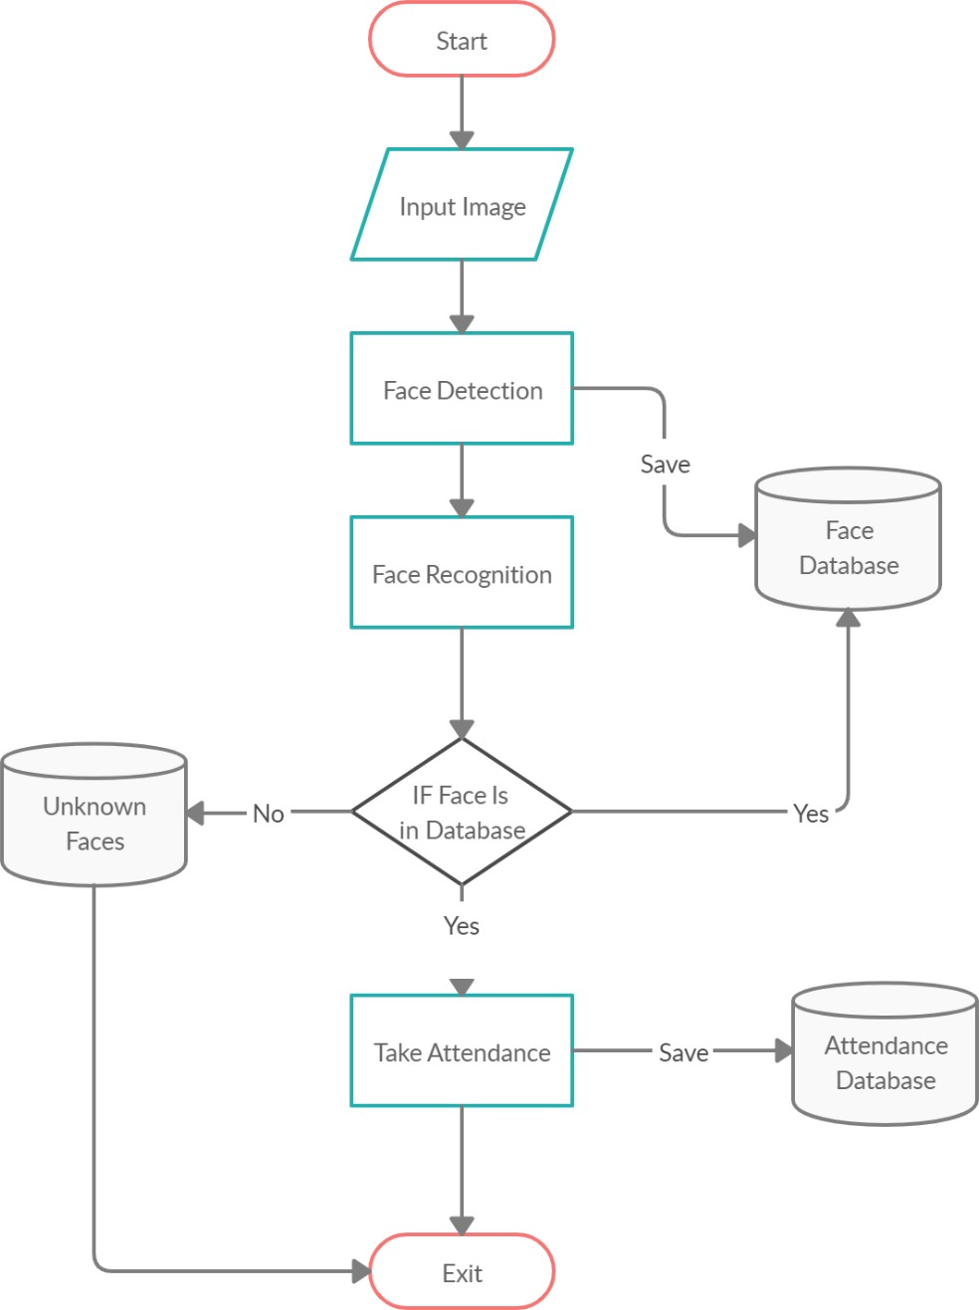

Fig: Flow Chart

## Scope of the project

The main intention of this project is to solve the issues encountered in the old attendance system while reproducing a brand new innovative smart system that can provide convenience to the institution. In this project, a website will be developed which is capable of recognizing the identity of each individual and eventually record down the data into a database system and will be able to provide visual access to the information. The followings are the project scopes:

* The targeted groups of the attendance monitoring system are the students and staff of an educational institution.
* Teachers should be able to register new accounts.
* The user’s face should be sensed and captured by the camera
* The database of the attendance management system can hold an individual’s information.
* The detected face’s data should be matched with the database
* The facial recognition process can be done for multiple persons at a time.

Chapter 2

Literature Review

## Student Attendance System

Arun Katara et al. (2017) mentioned disadvantages of RFID (Radio Frequency Identification) card system, fingerprint system and iris recognition system. RFID card system is implemented due to its simplicity. However, the user tends to help their friends to check in as long as they have their friend’s ID card. The fingerprint system is indeed effective but not efficient because it takes time for the verification process so the user has to line up and perform the verification one by one. However for face recognition, the human face is always exposed and contain less information compared to iris. Iris recognition system which contains more detail might invade the privacy of the user. Voice recognition is available, but it is less accurate compared to other methods. Hence, face recognition system is suggested to be implemented in the student attendance system.

|  |  |  |
| --- | --- | --- |
| **System Type** | **Advantage** | **Disadvantages** |
| RFID card system | Simple | Fraudulent usage |
| Fingerprint system | Accurate | Time-consuming |
| Voice recognition system |  | Less accurate compared to Others |
| Iris recognition system | Accurate | Privacy Invasion |

Table 2.1: Advantages & Disadvantages of Different Biometric System[1]

## Digital Image Processing

Digital Image Processing is the processing of images which are digital in nature by a digital computer[2]. Digital image processing techniques are motivated by three major applications mainly:

* + - Improvement of pictorial information for human perception
    - Image processing for autonomous machine application

1 Arun Katara et al., 2017

2 Anil K Jain, Lin Hong, Sharath Pankanti, and Ruud Bolle, Biometric Identification. IEEE, 2004

* + - Efficient storage and transmission.

## Image Representation in a Digital Computer

An image is a 2-Dimensional light intensity function

𝐟 (𝐱,𝐲) = 𝐫 (𝐱,𝐲) × 𝐢 (𝐱,𝐲) - (2.0)

Where, r (x, y) is the reflectivity of the surface of the corresponding image point. i (x,y) Represents the intensity of the incident light. A digital image f(x, y) is discretized both in spatial co-ordinates by grids and in brightness by quantization[3]. Effectively, the image can be represented as a matrix whose row, column indices specify a point in the image and the element value identifies gray level value at that point. These elements are referred to as pixels or pels.

Typically following image processing applications, the image size which is used is𝟐𝟓𝟔 × 𝟐𝟓𝟔, elements, 𝟔𝟒𝟎 × 𝟒𝟖𝟎 pels or 𝟏𝟎𝟐𝟒

× 𝟏𝟎𝟐𝟒 pixels. Quantization of these matrix pixels is done at 8 bits for black and white images and 24 bits for colored images (because of the three color planes Red, Green and Blue each at 8 bits)[4].

## Steps in Digital Image Processing

Digital image processing involves the following basic tasks:

* + - Image Acquisition - An imaging sensor and the capability to digitize the signal produced by the sensor.
    - Preprocessing – Enhances the image quality, filtering, contrast enhancement etc.
    - Segmentation – Partitions an input image into constituent parts of objects.
    - Description/feature Selection – extracts the description of image objects suitable for further computer processing.
    - Recognition and Interpretation – Assigning a label to the object based on the information provided by its descriptor.

3 N. Tom, Face Detection, Near Infinity - Podcasts, 2007

Interpretation assigns meaning to a set of labelled objects.

* + - Knowledge Base – This helps for efficient processing as well as inter module cooperation.

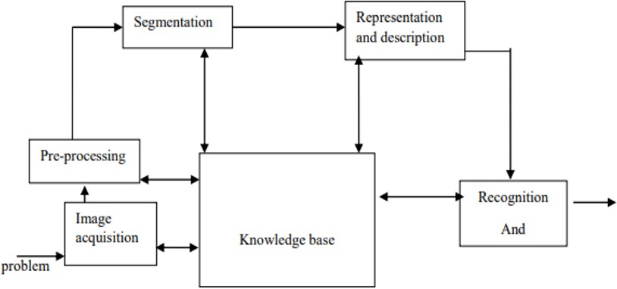

Fig: A diagram showing the steps in digital image processing

## Definition of Terms and History

##### Face Detection

Face detection is the process of identifying and locating all the present faces in a single image or video regardless of their position, scale, orientation, age and expression. Furthermore, the detection should be irrespective of extraneous illumination conditions and the image and video content[5].

##### Face Recognition

Face Recognition is a visual pattern recognition problem, where the face, represented as a three dimensional object that is subject to varying illumination, pose and other factors, needs to be identified based on acquired images[6].

Face Recognition is therefore simply the task of identifying an already detected face as a known or unknown face and in more advanced cases telling exactly whose face it is[7].

5 A. L. Rekha and H. K. Chethan, “Automated Attendance System using face Recognition through Video Surveillance,” Int. J. Technol. Res. Eng., vol. 1, no. 11, pp. 1327–1330, 2014.

6 I. Kim, J. H. Shim, and J. Yang, “Face detection,” Face Detect. Proj. EE368 Stanf. Univ., vol. 28, 2003.

7 E. Shervin, “OpenCV Computer Vision,” 03-Oct-2010

##### Difference between Face Detection and Face Recognition

Face detection answers the question, Where is the face? It identifies an object as a “face” and locates it in the input image. Face Recognition on the other hand answers the question who is this? Or whose face is it? It decides if the detected face is someone known or unknown based on the database of faces it uses to validate this input image[8].It can therefore be seen that face detections output (the detected face) is the input to the face recognizer and the face Recognition’s output is the final decision i.e. face known or face unknown.

##### Face Detection

A face Detector has to tell whether an image of arbitrary size contains a human face and if so, where it is. Face detection can be performed based on several cues: skin color (for faces in color images and videos, motion (for faces in videos), facial/head shape, facial appearance or a combination of these parameters. Most face detection algorithms are appearance based without using other cues. An input image is scanned at all possible locations and scales by a sub window. Face detection is posed as classifying the pattern in the sub window either as a face or a non-face. The face/nonface classifier is learned from face and non-face training examples using statistical learning methods[9]. Most modern algorithms are based on the Viola Jones object detection framework, which is based on Haar Cascades.

|  |  |  |
| --- | --- | --- |
| **Face Detection Method** | **Advantages** | **Disadvantages** |
| Viola Jones Algorithm | 1. High detection Speed. 2. High Accuracy. | 1. Long Training Time. 2.Limited Head Pose. 3.Not able to detect dark faces. |
| Local Binary Pattern Histogram | 1.Simple computation. 2.High tolerance against the  monotonic | 1.Only used for binary and grey images. 2.Overall performance is inaccurate compared to Viola-Jones  Algorithm. |

8 T. Matthew and A. Pentland, Eigenfaces for Recognition, vol. 3, Volume 3, Number 1 vols. Vision and Modelling Group, The Media Laboratory, MIT: Journal of Cognitive Neuroscience, 1991

9 Y.-Q. Wang, “An Analysis of the Viola-Jones Face Detection Algorithm,” Image Process. Line, vol. 4, pp. 128–148, Jun. 2014

|  |  |  |
| --- | --- | --- |
| **Face Detection Method** | **Advantages** | **Disadvantages** |
|  | illumination changes. |  |
| Ada Boost Algorithm | Need not to have any prior knowledge about face structure. | The result highly depends on the training data and affected by weak classifiers. |
| SMQT Features and SNOW Classifier Method | 1. Capable to deal with lighting problem in object detection. 2. Efficient in computation. | The region contain very similar to grey value regions will be misidentified as face. |
| Neural-Network | High accuracy only if large size of image were trained. | 1. Detection process is slow and computation is complex. 2. Overall performance is weaker than Viola-Jones   algorithm. |

Table: Advantages & Disadvantages of Face Detection Methods[10] Viola-Jones Algorithm

Viola-Jones algorithm which was introduced by P. Viola, M. J. Jones (2001) is the most popular algorithm to localize the face segment from static images or video frame. Basically the concept of Viola-Jones algorithm consists of four parts. The first part is known as Haar feature, second part is where integral image is created, followed by implementation of Adaboost on the third part and lastly cascading process.

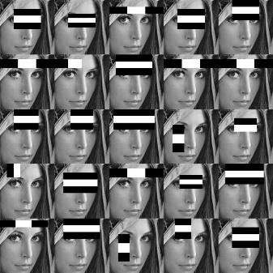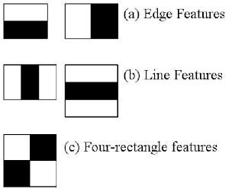

10 Varsha Gupta and Dipesh Sharma, 2014

Fig: Haar Feature

Viola-Jones algorithm analyses a given image using Haar features consisting of multiple rectangles (Mekha Joseph et al., 2016).

In the fig shows several types of Haar features. The features perform as window function mapping onto the image. A single value result, which representing each feature can be computed by subtracting the sum of the white rectangle(s) from the sum of the black rectangle(s) (Mekha Joseph et al., 2016).

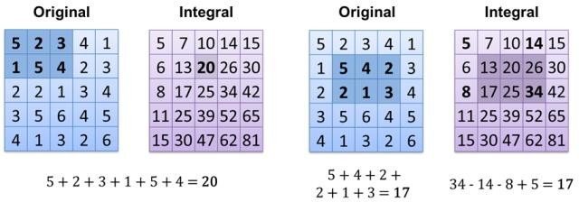

Fig: Integral of Image

The value of integrating image in a specific location is the sum of pixels on the left and the top of the respective location. In order to illustrate clearly, the value of the integral image at location 1 is the sum of the pixels in rectangle A. The values of integral image at the rest of the locations are cumulative.

For instance, the value at location 2 is summation of A and B, (A + B), at location 3 is summation of A and C, (A + C), and at location 4 is summation of all the regions, (A + B + C + D) [11]. Therefore, the sum within the D region can be computed with only addition and subtraction of diagonal at location 4 + 1 − (2 + 3) to eliminate rectangles A, B and C.

##### Local Binary Patterns Histogram

Local Binary Pattern (LBP) is a simple yet very efficient texture operator which labels the pixels of an image by thresholding the neighborhood of each pixel and considers the result as a binary number.

It was first described in 1994 (LBP) and has since been found to be a powerful feature for texture classification. It has further

11 Srushti Girhe et al., 2015

been determined that when LBP is combined with histograms of oriented gradients (HOG) descriptor, it improves the detection performance considerably on some datasets. Using the LBP combined with histograms we can represent the face images with a simple data vector.

##### LBPH algorithm work step by step:

LBPH algorithm work in 5 steps.

1. **Parameters:** the LBPH uses 4 parameters:
   * **Radius:** the radius is used to build the circular local binary pattern and represents the radius around the central pixel. It is usually set to 1.
   * **Neighbors:** the number of sample points to build the circular local binary pattern. Keep in mind: the more sample points you include, the higher the computational cost. It is usually set to 8.
   * **Grid X:** the number of cells in the horizontal direction. The more cells, the finer the grid, the higher the dimensionality of the resulting feature vector. It is usually set to 8.
   * **Grid Y:** the number of cells in the vertical direction. The more cells, the finer the grid, the higher the dimensionality of the resulting feature vector. It is usually set to 8.
2. **Training the Algorithm:** First, we need to train the algorithm. To do so, we need to use a dataset with the facial images of the people we want to recognize. We need to also set an ID (it may be a number or the name of the person) for each image, so the algorithm will use this information to recognize an input image and give you an output. Images of the same person must have the same ID. With the training set already constructed, let’s see the LBPH computational steps.
3. **Applying the LBP operation:** The first computational step of the LBPH is to create an intermediate image that describes the original image in a better way, by highlighting the facial characteristics. To do so, the algorithm uses a concept of a sliding window, based on the parameters radius and neighbors.

The image below shows this procedure:

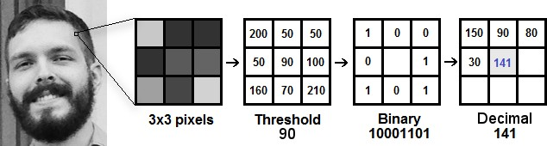

Fig: LBP Operation

Based on the image above, let’s break it into several small

steps so we can understand it easily:

* Suppose we have a facial image in grayscale.
* We can get part of this image as a window of 3x3 pixels.
* It can also be represented as a 3x3 matrix containing the intensity of each pixel (0~255).
* Then, we need to take the central value of the matrix to be used as the threshold.
* This value will be used to define the new values from the 8 neighbors.
* For each neighbor of the central value (threshold), we set a new binary value. We set 1 for values equal or higher than the threshold and 0 for values lower than the threshold.
* Now, the matrix will contain only binary values (ignoring the central value). We need to concatenate each binary value from each position from the matrix line by line into a new binary value (e.g. 10001101). Note: some authors use other approaches to concatenate the binary values (e.g. clockwise direction), but the final result will be the same.
* Then, we convert this binary value to a decimal value and set it to the central value of the matrix, which is actually a pixel from the original image.
* At the end of this procedure (LBP procedure), we have a new image which represents better the characteristics of the original image.

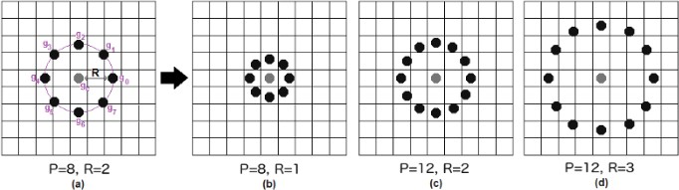

Fig: The LBP operation Radius Change

It can be done by using bilinear interpolation. If some data point is between the pixels, it uses the values from the 4 nearest pixels (2x2) to estimate the value of the new data point.

1. **Extracting the Histograms:** Now, using the image generated in the last step, we can use the Grid X and Grid Y parameters to divide the image into multiple grids,

as can be seen in the following image:

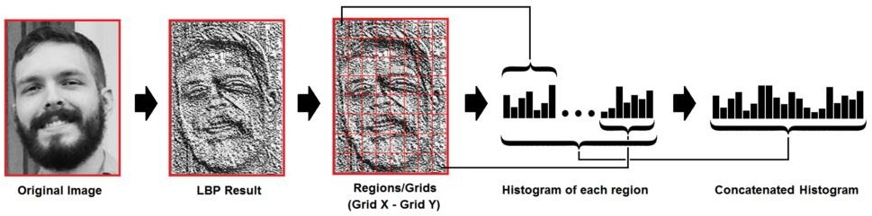

Fig: Extracting The Histogram

Based on the image above, we can extract the histogram of each region as follows:

* + As we have an image in grayscale, each histogram (from each grid) will contain only 256 positions (0~255) representing the occurrences of each pixel intensity.
  + Then, we need to concatenate each histogram to create a new and bigger histogram. Supposing we have 8x8 grids, we will have 8x8x256=16.384 positions in the final histogram. The final histogram represents the characteristics of the image original image.

1. **Performing the face recognition:** In this step, the algorithm is already trained. Each histogram created is

used to represent each image from the training dataset. So, given an input image, we perform the steps again for this new image and creates a histogram which represents the image.

* + So to find the image that matches the input image we just need to compare two histograms and return the image with the closest histogram.
  + We can use various approaches to compare the histograms (calculate the distance between two histograms), for example: Euclidean distance, chi-square, absolute value, etc. In this example, we can use the **Euclidean distance** (which is quite known) based on the following formula:

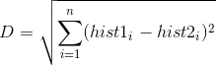

* + So the algorithm output is the ID from the image with the closest histogram. The algorithm should also return the calculated distance, which can be used as a ‘confidence’ measurement. Note: don’t be fooled about the ‘confidence’ name, as lower confidences are better because it means the distance between the two histograms is closer.
  + We can then use a threshold and the ‘confidence’ to automatically estimate if the algorithm has correctly recognized the image. We can assume that the algorithm has successfully recognized if the confidence is lower than the threshold defined.

Chapter 3

Methodology

## Introduction

Face detection involves separating image windows into two classes; one containing faces (turning the background (clutter). It is difficult because although commonalities exist between faces, they can vary considerably in terms of age, skin color and facial expression. The problem is further complicated by differing lighting conditions, image qualities and geometries, as well as the possibility of partial occlusion and disguise. An ideal face detector would therefore be able to detect the presence of any face under any set of lighting conditions, upon any background. The face detection task can be broken down into two steps. The first step is a classification task that takes some arbitrary image as input and outputs a binary value of yes or no, indicating whether there are any faces present in the image. The second step is the face localization task that aims to take an image as input and output the location of any face or faces within that image as some bounding box with (x, y, width, height). After taking the picture the system will compare the equality of the pictures in its database and give the most related result.

## Tools and Technologies

## Tools and techniques used in the project are described in this section of the thesis. This project focused was mainly focused on Python Programming and its libraries.

## Python

Python is a high-level object-oriented programming language. It was created by Guido van Rossum in 1991 as Python 0.9.0. It was created as the successor of the ABC programming language. Python 2.0 was released on 16 October 2000 and added many features like list comprehension and garbage collecting system. On 3 December 2008, Python 3.0 was released. Python is a very popular programming language and can be used for various purposes. It is widely used for web development, software development, mathematics and data analysis, system scripting, etc. Python is a multi-purpose programming language that works on different platforms like Windows, Linux, Mac, Raspberry Pie, etc. Python is popular than other programming languages because it has a simple syntax than other programming languages. Its syntax allows the programs to write code that is easier to understand and in fewer lines. It runs in an interpreter system. Hence, the code can be executed as soon as it is written. In this thesis, we use Python for web development. This project demonstrated how Python is used for an effective and reliable web application. Various Python frameworks, libraries are used in this project.

## Django

Django is a high-level web framework based on python. Django was developed between 2003 and 2005 by a team responsible for creating and maintaining newspaper sites. It has continued to grow by releasing Django 1.0 in 2008 through the latest Django 3.1 in 2020. It enables users with rapid and secure development of the websites. It is open source, free with a thriving community, and has up-to-date documentation. Any kind of website can be built using Django. It works on any framework and delivers content in any format (JSON, HTML, XML, etc). Django provides a security framework that helps developers protect their websites. Django uses component-based architecture. It means each component is independent of the other, hence can be easily changed or replaces if needed. It provides a clear separation of different parts that enables to scale for increased traffic at any level by adding hardware. Django uses the Do Not Repeat Yourself (DRY) principle. Hence, there is no unnecessary repetition of code. Django is written in Python and hence, can be run on my platforms.

## OpenCv

OpenCV is an open-source machine learning and computer vision library. OpenCV is a cross-platform library and is free to use. It was launched in 1999. Intel launched OpenCV to advance CPU-intensive applications. It was developed in C++. It provides bindings for Java and Python programming languages. It runs in different operating systems such as Linux, Windows, OSx, etc. It focuses mainly on video capturing, image processing, and analysis. It has face detection and objects detection features. OpenCV can be used to read and write images and capture and save videos. It can perform feature detection like faces, cars, images, etc. Many established companies like Yahoo, Google, Microsoft, Intel, and many others use the library.

## Model Implementation

This section describes how the algorithm was implemented to design the system and the testing of the system. The application was created using Python’s Django framework. Both the front-end and back-end of the project were done using Django. This project implements the tools and technologies mentioned in section 3.2.

## System Design

## This system is a web-based application where registered teachers

### Presentation Layer

### This layer is responsible for the user interface. All the components that users see and interact with within the application are in this layer.

Application Layer

Application layer controls the overall functionality of the system. Functionality such as logging into the system, facial detection, and recognition is all done in this layer.

Data Layer.

### In this layer, Data and Information are stored and retrieved in the database. The names, images of students as datasets, teaches are stored in the database.

### Once the face is matched, marking of attendance in the database. See next figure.

### 

### System Design

#### Database Design

#### For this project, the default Django SQLite was used to create the database. The tables are created by Django’s model. It provides an ORM to the underlying database. ORM makes it easy to work with relational databases. The models in Django are Object, which is mapped to the database. When a model is created, Django creates the corresponding table without having to write any SQL code.

#### 

#### Django model and its corresponding table in the database.

#### Creating a model in Django is easy. It contains essential fields needed for our data and specifies the behavior of the data. Each model is mapped to a single table in the database. Models in python are classes that subclass Django.db.models.Model.

#### C:\Users\SAMUEL\Documents\MINI-PROJECT\pics\teacherModel.png

#### Teacher Model

#### The teacher models container fields like email, username, firstname, lastname, registration\_id, faculty, department, course, gender, date, profile\_pic, about, is\_staff, is\_active, objects with contains list of students, which is imported from the Django library as shown in the figure above.

#### C:\Users\SAMUEL\Documents\MINI-PROJECT\pics\studentModel.png

#### Student Model.

#### This is a model to record the student information. The student model container fields such as firstname, lastname and gender as shown in the figure above. In the profile\_pic field, images of a particular student are stored as the dataset. These images are used to compare the detected face during facial recognition.

#### C:\Users\SAMUEL\Documents\MINI-PROJECT\pics\attendanceModel.png

#### The attendance model keeps the attendance record. It has a Student\_id, date, time, faculty, department, course, year, period, and status fields.

#### Interface Design

#### The user interface in Django was created by implementing Django templates. It is the primary tool to create a user interface in Django. Django templates create HTML interface, which is rendered by Django view. In Django, views can be created as a class and a function. View created by function is called function- based view and view created by class is called a class-based view.

#### 

#### Function-based view for Login and Logout.

The figure above shows an example of function-based views. It has two functions loginPage and logoutUser view. In login\_view, if the user is authenticated, it redirects the user to the home page.The user is redirected to the login page when signed out.

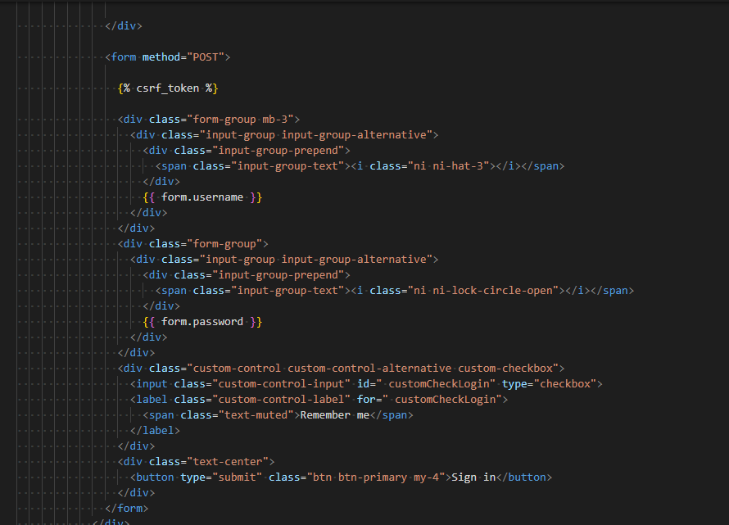

The figure above shows an HTML template file for login. This HTML file would be rendered by Django views.

#### C:\Users\SAMUEL\Documents\MINI-PROJECT\pics\login.png

#### Login Interface

#### The figure above shows the login page of the website. Here the teachers can log in to the system. New Teachers can also create new accounts by clicking on the register text.

#### 

#### C:\Users\SAMUEL\Documents\MINI-PROJECT\pics\register.png

#### C:\Users\SAMUEL\Documents\MINI-PROJECT\pics\register-2.png

#### Create New Account.

#### In the figure above, we can see the form the teacher needs to fill to create a new account. Information like first name, last name, username, email, registration ID, faculty, department, gender and password should be filled in.

#### C:\Users\SAMUEL\Documents\MINI-PROJECT\pics\add_student.png

#### C:\Users\SAMUEL\Documents\MINI-PROJECT\pics\add_student2.png

#### Add Student by teacher.

#### Similarly, as shown in the figure above, Teachers can also add student to the system. The teacher needs to provide student’s information that is shown in the figure above. In the image path of the data set images of a student is provided. The scanned image is compared with the images stored in the data set from this path.

#### C:\Users\SAMUEL\Documents\MINI-PROJECT\pics\student.png

#### C:\Users\SAMUEL\Documents\MINI-PROJECT\pics\student2.png

#### Teacher Interface.

#### The figure above shows the teacher’s interface after the teacher has logged into the system. Here the teacher can see the list of students, create a new student by clicking the new student button, edit student details by clicking on the update student button and view the list of attendances by clicking on today’s attendance.

#### C:\Users\SAMUEL\Documents\MINI-PROJECT\pics\search_attendance.png

#### Attendance Page

The figure above shows the attendance page. The teacher is required

to input information required above to start the scan process.

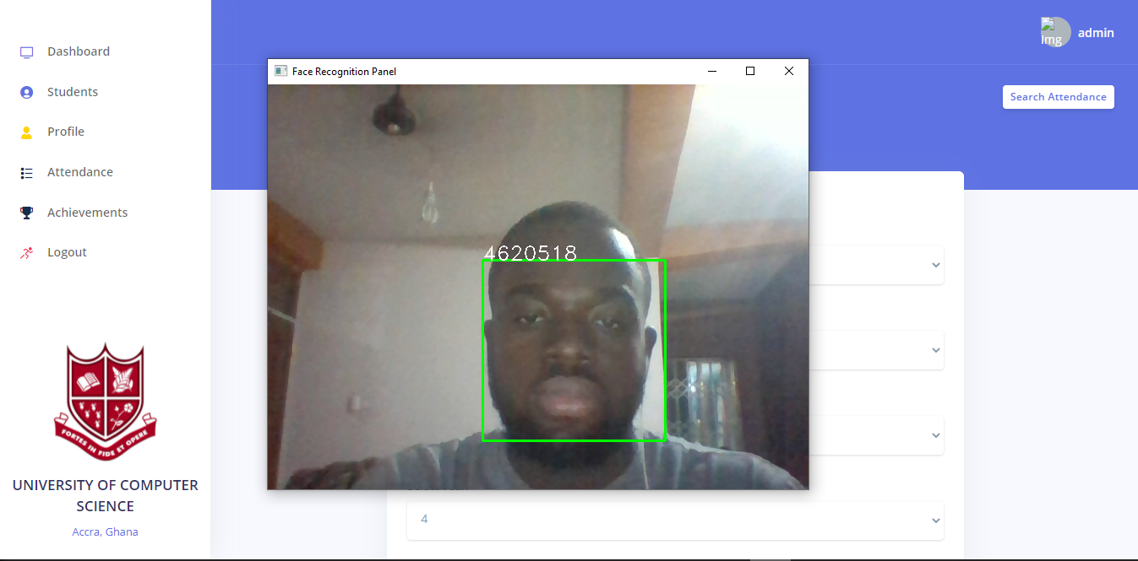

Face Scan.

The figure above shows the camera windows when taking new attendance. When the teacher takes new attendance, the camera windows open to scan the face. Once the camera detects the face, it covers the face with a blue square. Once the face has been scanned, it is compared with the images stored in the dataset. If it matches with images in the dataset, it marks the students present. The student report is display right after the process is completed as show below.



Attendance List.

Chapter 4

Implementation and Results

As this was a small-scale project, data structure and implementation did not have many problems. However, it took the me many efforts with research and study with different technologies needed as these tools and technologies were new me. This caused a delay in the development of the project. Despite the delay and difficulties, I was able to incorporate those tools and technologies and complete the project. However, the success rate of facial recognition was not as expected. The success rate depended upon the quality of the camera, lighting, and sufficient dataset in the database. When these factors were to be managed properly, the success rate of face recognition increased.

The effort that went to learn and research about LBPH and Django and other tools and technologies was worth it. While the process of researching and implementing was overwhelming, it started to be interesting as the project started to show some results. This project gave me first-hand experience in working on a project using Django and found Django easier and more scalable.

Chapter 5

Conclusion and Recommendations

The goal of the project was to build a facial recognition system for student’s attendance. Concepts of facial recognition and LBPH is heavily discussed in this thesis. Similarly, web development with Django is also discussed, followed by examples of implementation and explanations.

The result of the project was a successful prototype of a facial recognition system where the teacher can create an account and add students and their information to the database. Teachers then can log in to the system and take attendance of the student. The student’s face is detected by a camera and attendance is recorded in the database. Teachers could see the attendance report of the students.

Overall, the project was successful in its showcasing how LBPH can be implemented in Django to create a web application. Once implemented, it can be used to take attendance of students and keep track of their attendance records. This project has the potential for further development in the future by adding more features for students and teachers. More features such as assignments, results, and grades could be added.